**B- Tree Example**

A B tree of order 4 is shown in the following image.

No. of Children = 4

No. of Keys = 4 – 1 = 3

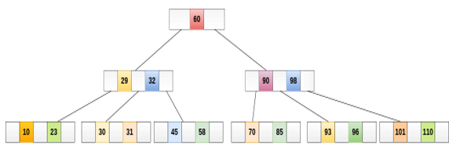

**Searching :**

For example, if we search for an item 31 in the following B Tree. The process will something like following :

1. Compare item 31 with root node 60. since 31 < 60 hence, move to its left sub-tree.
2. Since, 29<31<32, traverse right sub-tree of 29.
3. 31>30, move to right. Compare 31.
4. match found, return.

**Inserting :**

Insert the node 8 into the B Tree of order 5 shown in the following image.

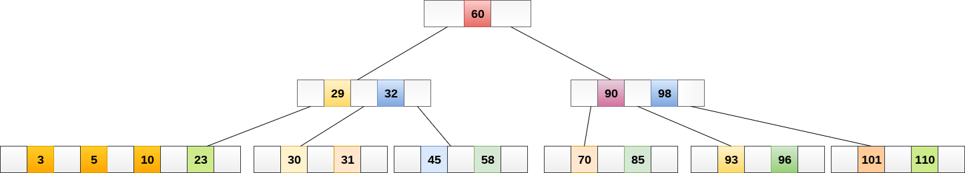

8 will be inserted to the right of 5, therefore insert 8.

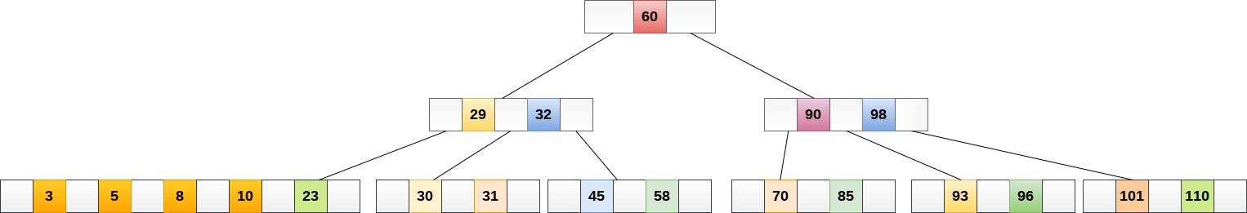

The node, now contain 5 keys which is greater than (5 -1 = 4 ) keys. Therefore split the node from the median i.e. 8 and push it up to its parent node shown as follows.

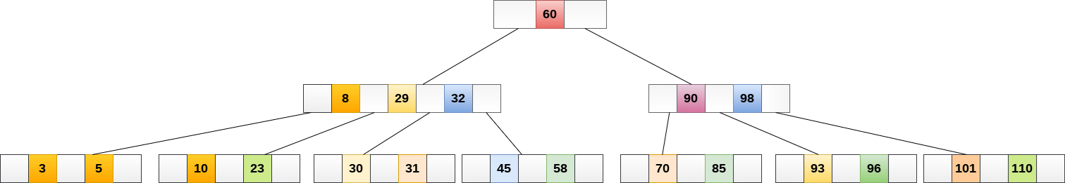

**Deletion**

Delete the node 53 from the B Tree of order 5 shown in the following figure.

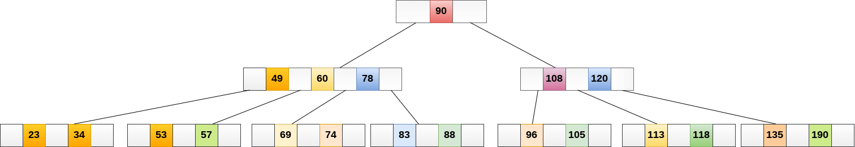

53 is present in the right child of element 49. Delete it.

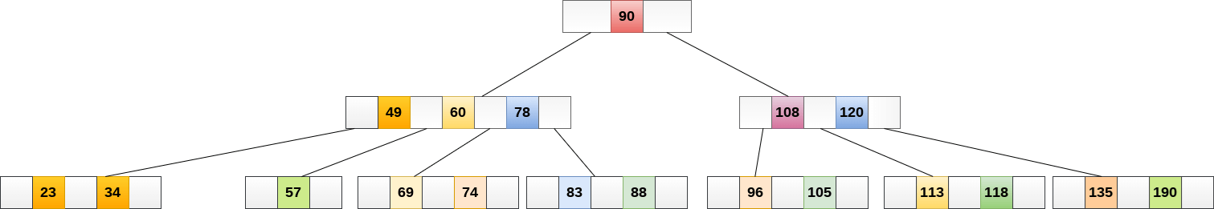

Now, 57 is the only element which is left in the node, the minimum number of elements that must be present in a B tree of order 5, is 2. it is less than that, the elements in its left and right sub-tree are also not sufficient therefore, merge it with the left sibling and intervening element of parent i.e. 49.

The final B tree is shown as follows.

